1 and 2.

SELECT ST_POINT(-93.610065, 41.948637) AS point1;

SELECT ST_DISTANCE(

ST_POINT(-93.610065, 41.948637),

ST_POINT(-93.610229, 41.997339)

) AS distance_in_degrees;

3.

WITH line AS (

SELECT ST_LINESTRING(

ARRAY[

ST_POINT(-93.610065, 41.948637),

ST_POINT(-93.610229, 41.997339)

]

) AS line_string

),

point AS (

SELECT ST_POINT(-93.619738, 41.972017) AS point3

)

SELECT

ST_DISTANCE(line_string, point3) AS distance_in_degrees

FROM

line, point;

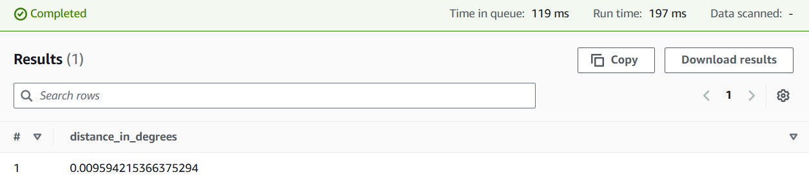

4.

WITH line AS (

SELECT ST_LINESTRING(

ARRAY[

ST_POINT(-93.610065, 41.948637),

ST_POINT(-93.610229, 41.997339)

]

) AS line_string

),

point AS (

SELECT ST_POINT(-93.619738, 41.972017) AS point3

)

SELECT

ST_DISTANCE(line_string, point3) * 364567 AS distance_feet

FROM

line, point;

5.

WITH line AS (

SELECT ST_LINESTRING(

ARRAY[

ST_POINT(-93.610065, 41.948637),

ST_POINT(-93.610229, 41.997339)

]

) AS line_string

),

point AS (

SELECT ST_POINT(-93.619738, 41.972017) AS point3

)

SELECT

ST_DISTANCE(line_string, point3) * 364567 AS distance_feet

FROM

line, point;

